* I made a program to manage appointments at a beauty salon.
* I created the database in Microsoft SQL Server and I implemented a variety of features.
* The visual interface it is done in Java Swing and all the code is written in Java.
* I have: Insert, update, delete ( for 2 diffrent tables).
* 6 simple queries using JOIN.
* 4 complex queries using aggregate functions and sub-requests.
* Other queries as well.

**Database Diagram:**

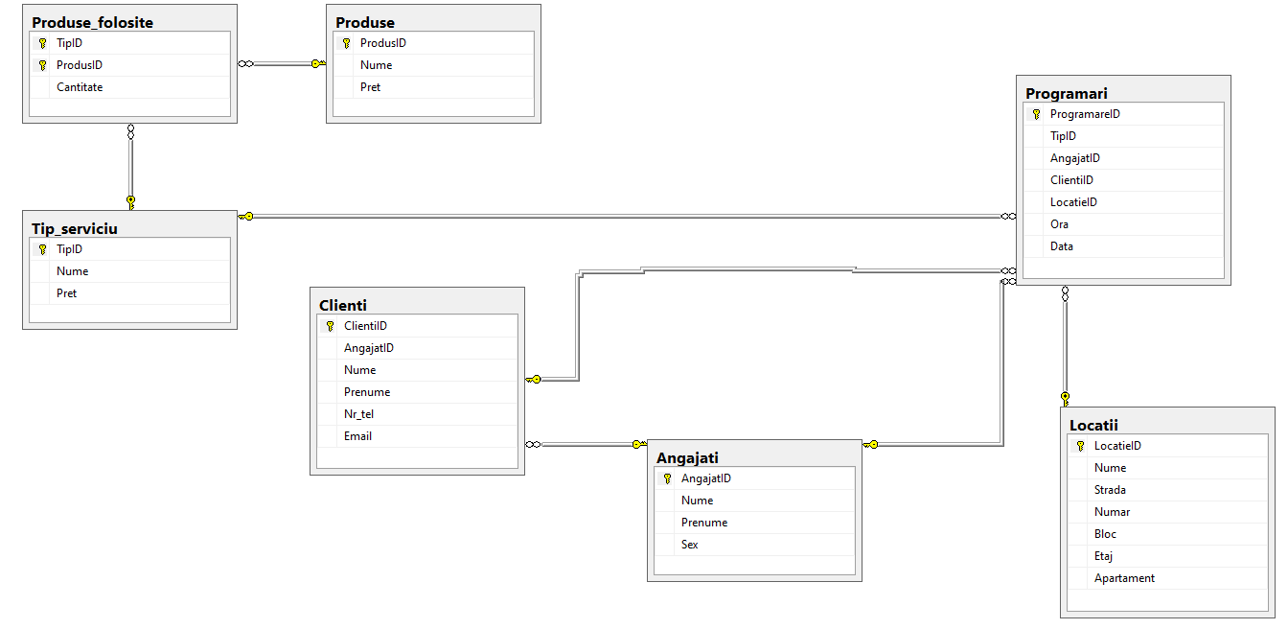

**Visual interface:**

